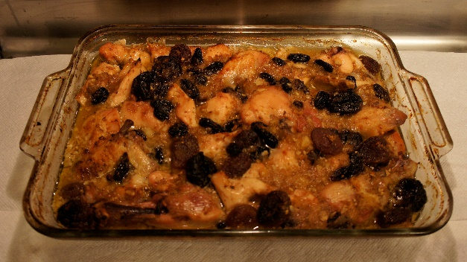
Pineapple/Dried Fruit Chicken Casserole
- 2 3½-pound chickens, cut into pieces
- 3 tablespoons oil
- 3 tablespoons brown sugar
- 2 cups water
- 1 clove garlic, crushed
- ¼ teaspoon salt
- ¼ teaspoon pepper
- ½ cup crushed almonds
- 10 prunes, pitted
- 8 dried apricots
- ½ cup jumbo raisins
- 1 8-ounce can crushed pineapple
Place chicken in a baking pan and bake in a preheated 350° oven for 30 minutes. Meanwhile, in a skillet, heat oil, add crushed garlic, salt and pepper. Stir in nuts and add water. Bring to a boil. Add dried fruits and pineapple. Cook for 10 minutes. Pour this sauce over pre-baked chicken and bake an additional 45 minutes until tender.

